****4****

**December is National Safe Toys**

**and Gifts Month**

**Safety tips for this holiday season:**

**Balloons**Children can choke or suffocate on deflated or broken balloons. Keep deflated balloons away from children younger than eight years old. Discard broken balloons immediately.

**Small balls/other toys with small parts**For children younger than age three, avoid toys with small parts, which can cause choking.

**Scooters and other riding toys** Riding toys, skateboards and in-line skates go fast, and falls could be deadly. Helmets and safety gear should be worn properly at all times and should be sized to fit.

**Magnets** High-powered magnet sets are dangerous and should be kept away from children. Whether marketed for children or adults, building and play sets with small magnets should also be kept away from small children.

Once gifts are open: Immediately discard plastic wrapping or packaging before they become dangerous play things. Keep toys appropriate for older children away from younger siblings. Battery charging should be supervised by adults. Chargers and adapters can pose thermal burn hazards to young children. Pay attention to instructions and warnings on battery chargers. Some chargers lack any mechanism to prevent overcharging.

**Toy Safety Guides The** CPSC provides free safety alerts, guides, posters, brochures, handbooks and other materials which you can use to help spread consumer product safety information in your community. **Source**: http://www.cpsc.gov/en/Newsroom/News-Releases/2014/Global-System-of-Toy-Safety-Works-to-Keep-Kids-Safe-This-Holiday-Season-Recalls-Down-Port-Seizures-Up-/

[Comments (-1)](http://www.bostonpublicschools.org/site/default.aspx?PageType=3&ModuleInstanceID=1518&ViewID=C9E0416E-F0E7-4626-AA7B-C14D59F72F85&RenderLoc=0&FlexDataID=8834&PageID=920)





Franklin D Roosevelt K-8 School

Big Time News- December 17, 2015

**Principals Corner**

 I can’t believe how quickly this month has gone by! We have had a successful conclusion of our BOKS before school and our Soccer program, and Debate Mate is on break till January 27th.

Great news: our Robotics Program’s Donor’s Choose project has been funded and the materials will arrive in the New Year.

Please read below about our Celtics Visit our students earned for reading more than any other school in the Read Boston program last month!

I wish each Roosevelt family a restful and safe vacation week. School will be closed from Thursday December 24th to Monday January 4th and will re-open Tuesday January 5th.

C:\Users\039467\AppData\Local\Microsoft\Windows\Temporary Internet Files\Content.IE5\EFXCH4M4\blockpage[1].gif

**Technology Corner**

Live Butterfly Garden App

Create your own butterfly and observe as it grows through its

life cycle. Children can name their own butterfly as they learn

about the life cycle of a butterfly

**Lost & Found**

Parents we have a variety of recovered items already including new coats, jackets, hats & gloves and sweaters too. If your child is missing any of the above feel free to check our lost and found box in the LC gym and at in the cafeteria at upper campus. Please write your child’s name inside each big clothing item so we can easily return it to you! After the 1st of the year we donate the clothing to goodwill. Thank you!!

**Globe Santa**

Due to the generosity of students we sent a check to Globe Santa for $293.20. Thanks to all who participated for your concern and generosity to help make the holidays a little brighter for many Boston area children and families.

**Technology Corner**

Technology meeting Wednesday, December 22 @ 7:15am LC.

**WEBSITES APPS**

Ixl.com Students in grades Pre-K to Mathematics 8 can practice math and Language Arts language art skills which are aligned

with state standards.

**Read to Achieve**

**Boston Celtics Visit**

Students in grades K2-5th recently received a special visit from Celtics player Marcus Smart, Veteran player, Lucky the Mascot and a Celtics dancer!   Our strong reading efforts in November awarded us this very special assembly.  Each student received the book Jemanji, and the Celtics players read the story with the students. We got to hear personal stories from the players and some students were able to ask the players questions. Prizes for all students who completed the required reading in November will be delivered before the break.  The Celtics also announced that all Roosevelt students who are participating in the Read to Achieve program will have a chance to attend a Celtics game this school year!  Make sure you continue reading, completing your reading logs, and doing the optional writing assignments!

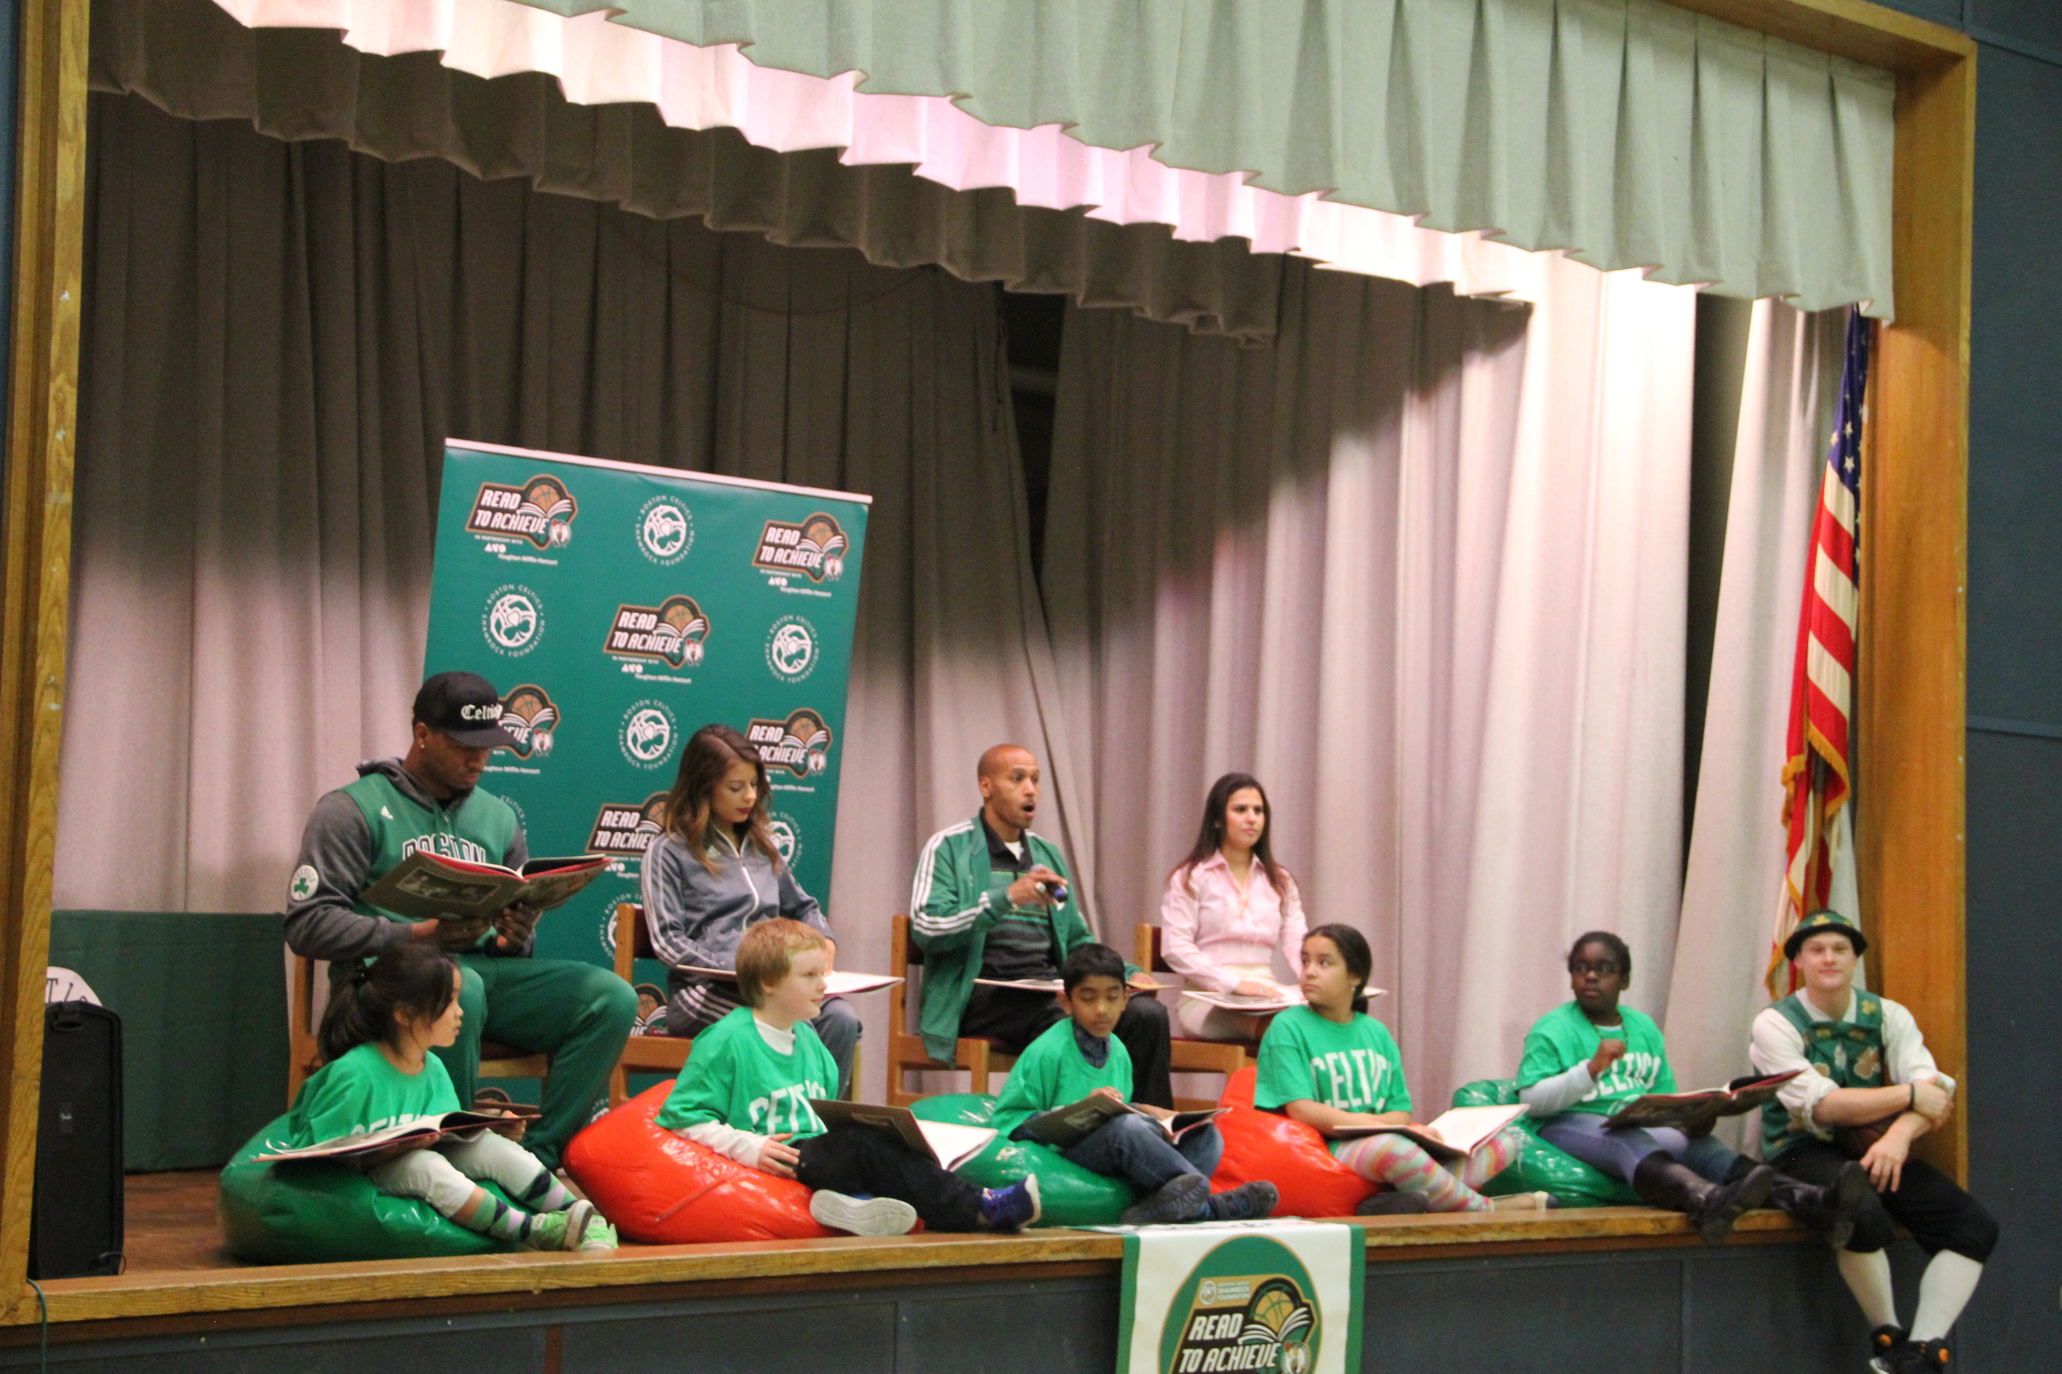

**7th and 8th Grade Science**

Seventh grade science just finished the first unit of the year, Forces and Motion, and is beginning Earth History.  Congratulations to Chimkachi Celestine-Albert and Daniel Portillo, who won the first term science awards for having the highest average in their class.

Eighth grade science is wrapping the first unit of the year and spending the next few weeks learning about genetics.  Grade eight will be getting ready to start preparing for MCAS when we return to school in January.  Congratulations to Jada Coplin and Richard Gomez, who won the first term awards for having the highest average in their class.  For those who want to improve their science grade, Ms. Nissley is available for after school help with science on Mondays.

In the spring, all students will have the opportunity to participate in a Harvard Medical School project called “Reflection In Action.”  Stay tuned for more information coming soon!

**Girl Scouts Cookie Sales!**

Girl Scout cookies will be on sale just in time for the Holidays! Please email Mrs. Peterson at [awongpeterson@hotmail.com](mailto:awongpeterson@hotmail.com) if you want to place an order!

Cookie sales will also happen at dismissal ( Lower Campus on December 18, 21, 23 and Upper Campus on December 18) and at the Lower Campus holiday show on December 23rd!

**Franklin D. Roosevelt School**

**Principal Lynda-Lee Sheridan**

**Assistant Principal Bannet Steele**

**Upper Campus**: 95 Needham Road, Hyde Park, MA 02136

P: 617-635-8676

F: 617-635-8679

**Lower Campus**: 30 Millstone Road, Hyde Park, MA 02136

P: 617-635-9280

F: 617-635-9284

Please visit our website at **bostonpublicschools.org/roosevelt**

to find all general information about the school and classroom web pages.

**Don’t Be Late, Be Smart!**

We have noticed an increase in students being tardy for school recently. When students are late they miss important learning time and disrupt the class when they enter. Please prepare your book bag, pack up your homework and lay out your clothes at night so you can get to school on time every day! Don’t forget all students have free breakfast at school too. Students are tardy after 8:30 AM.

Scholars of The Month

We had a misprint in our recent newsletters, sorry!

Cooperation K -1 Green Room (October) Sofia

Curiosity Grade 1 Blue Room (December) Brenden

